**a. Create tables according to the following definition.**

CREATE TABLE DEPOSIT (ACTNO VARCHAR2(5),CNAME VARCHAR2(18) , BNAME VARCHAR2(18) , AMOUNT NUMBER(8,2) ,ADATE DATE);

CREATE TABLE BRANCH(BNAME VARCHAR2(18),CITY VARCHAR2(18));

CREATE TABLE CUSTOMERS(CNAME VARCHAR2 (19),CITY VARCHAR2(18));

CREATE TABLE BORROW(LOANNO VARCHAR2(5), CNAME VARCHAR2(18), BNAME VARCHAR2(18), AMOUNT NUMBER (8,2));

**b. Insert the data as shown below:**

|  |  |  |  |  |
| --- | --- | --- | --- | --- |
| **DEPOSIT: ACTNO** | **CNAME** | **BNAME** | **AMOUNT** | **ADATE** |
| 100 | ANIL | VRCE | 1000.00 | 1-MAR-95 |
| 101 | SUNIL | AJNI | 5000.00 | 4-JAN-96 |
| 102 | MEHUL | KAROLBAGH | 3500.00 | 17-NOV-95 |
| 104 | MADHURI | CHANDI | 1200.00 | 17-DEC-95 |
| 105 | PRAMOD | M.G.ROAD | 3000.00 | 27-MAR-96 |
| 106 | SANDIP | ANDHERI | 2000.00 | 31-MAR-96 |
| 107 | SHIVANI | VIRAR | 1000.00 | 5-SEP-95 |
| 108 | KRANTI | NEHRU PLACE | 5000.00 | 2-JUL-95 |
| 109 | MINU | POWAI | 7000.00 | 10-AUG-95 |

|  |  |
| --- | --- |
| **BRANCH: BNAME** | **CITY** |
| VRCE | NAGPUR |
| AJNI | NAGPUR |
| KAROLBAGH | DELHI |
| CHANDI | DELHI |
| DHARAMPETH | NAGPUR |
| M.G.ROAD | BANGLORE |
| ANDHERI | BOMBAY |
| VIRAR | BOMBAY |
| NEHRU PLACE | DELHI |
| POWAI | BOMBAY |

|  |  |
| --- | --- |
| **CUSTOMERS: CNAME** | **CITY** |
| ANIL | CALCUTTA |
| SUNIL | DELHI |
| MEHUL | BARODA |
| MANDAR | PATNA |
| MADHURI | NAGPUR |
| PRAMOD | NAGPUR |
| SANDIP | SURAT |
| SHIVANI | BOMBAY |
| KRANTI | BOMBAY |
| NAREN | BOMBAY |

|  |  |  |  |
| --- | --- | --- | --- |
| **BORROW: LOANNO** | **CNAME** | **BNAME** | **AMOUNT** |
| 201 | ANIL | VRCE | 1000.00 |
| 206 | MEHUL | AJNI | 5000.00 |
| 311 | SUNIL | DHARAMPETH | 3000.00 |
| 321 | MADHURI | ANDHERI | 2000.00 |
| 375 | PRAMOD | VIRAR | 8000.00 |
| 481 | KRANTI | NEHRU PLACE | 3000.00 |

From the above given tables perform the following queries:

(1) Describe branch, borrow, customer.

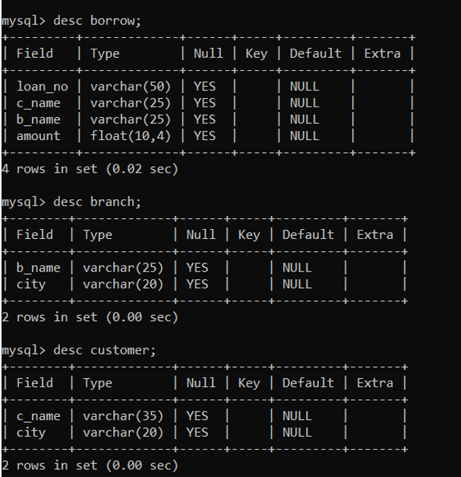

(2) Describe deposit.

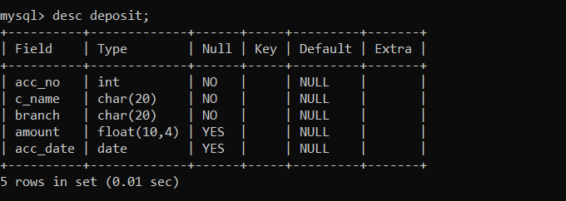

(3) List all data from table DEPOSIT.

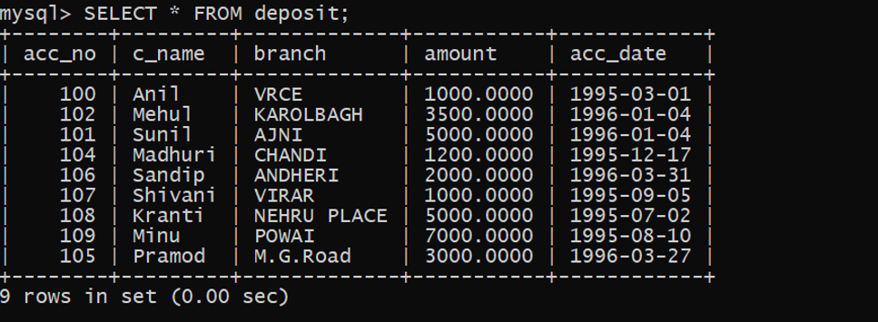

(4) List all data from table BORROW.

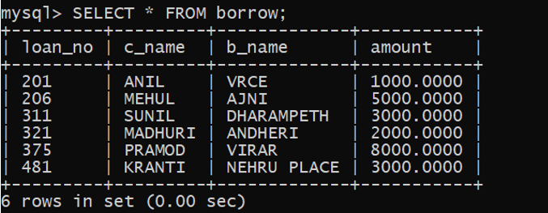

(5) List all data from table CUSTOMERS.

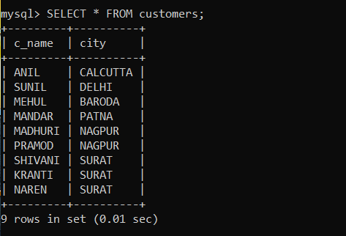

(6) List all data from table BRANCH.

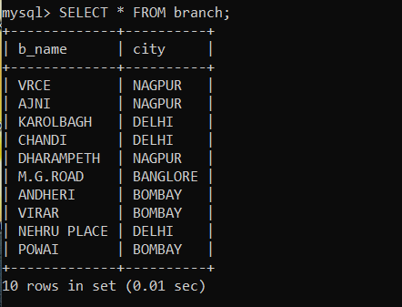

(7) Give account no and amount of depositors.

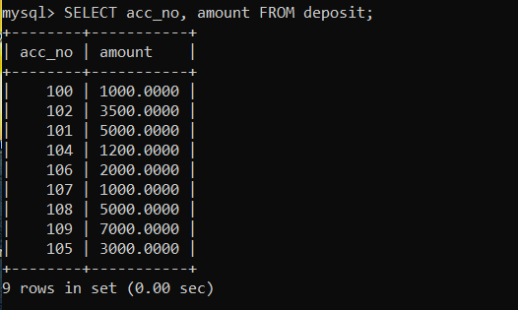

(8) Give name of depositors having amount greater than 4000.

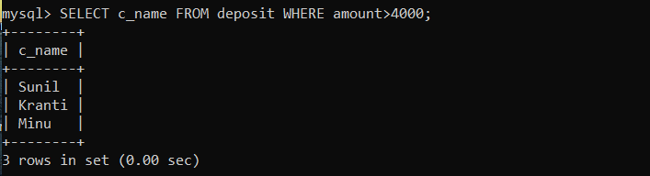

(9) Give name of customers who opened account after date '1-12-95'.

